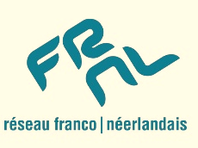
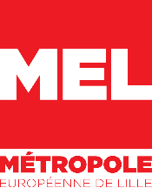

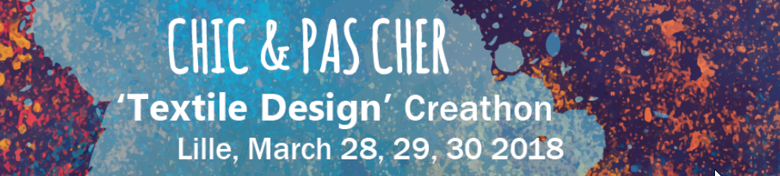
Application form (please fill in digitally)
Name: Cliquez ou appuyez ici pour entrer du texte.
Date of birth: Cliquez ou appuyez ici pour entrer du texte.
University: Cliquez ou appuyez ici pour entrer du texte.
Field of study: Cliquez ou appuyez ici pour entrer du texte.
BA ☐ in Cliquez ou appuyez ici pour entrer une date.
Master ☐ in Cliquez ou appuyez ici pour entrer une date.
PhD ☐ in Cliquez ou appuyez ici pour entrer une date.
Postal address:Cliquez ou appuyez ici pour entrer du texte.
/ @ : Cliquez ou appuyez ici pour entrer du texte. / Cliquez ou appuyez ici pour entrer du texte.

1) Explore the Lille Metropole and your own city region via maps, websites, books and your personal travel experiences if any. What is your perception of this European territory? Which territorial links and collaborations exist in the field of textile (design, arts, industries, innovation, new technologies, fashion, medicine etc.)?
Cliquez ou appuyez ici pour entrer du texte.

2) How can the Lille Metropolis, Belgium and the Netherlands innovate and strengthen their mutual ties in the various domains in which textile is used?
Cliquez ou appuyez ici pour entrer du texte.

3) Please join a brief CV and a recent, high-resolution profile picture to this application form.

Students and young professionals between 18 and 30 years old can apply for this event which is open to all disciplines. All events will be held in English. All costs related to participation (travel, meals, lodging) will be covered by the organizers.
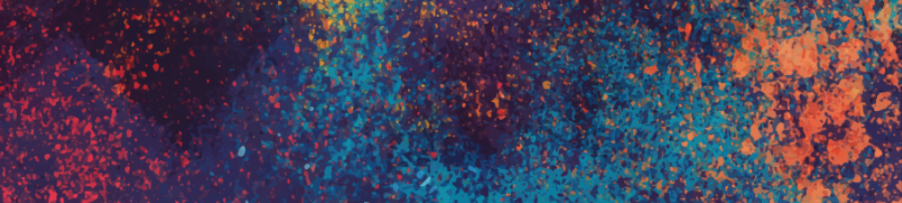
Please send your application to Magalie Herlem and Christiaan Seemann
mherlem@lillemetropole.fr I christiaan.seemann@univ-lille3.fr
http://www.mel.fr I http://nlfr.eu/

