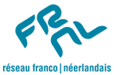

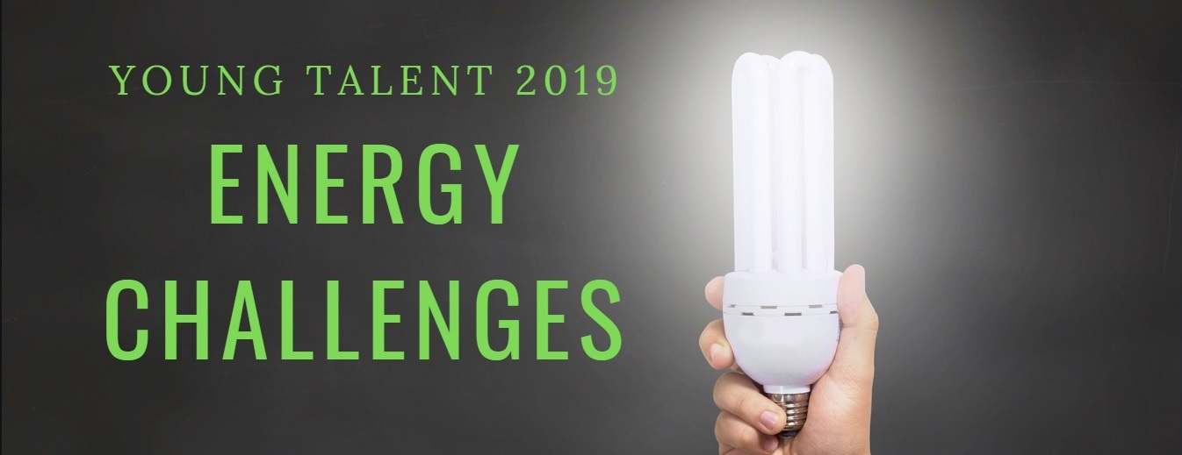
Application form
Name:
Date of birth:
University:
Discipline/Field of study:
Diploma and year of (expected) graduation: Master: in ____ PhD: in ____
Postal address:
Telephone number and e-mail address:

1) Briefly describe your relationship to the main theme of the meeting: Energy challenges. What projects regarding this subject have you been or are you currently working on? Why do you consider yourself to be a Young Talent when it comes to Energy challenges? (Maximum half a page in English)

2) What are your preliminary ideas for innovative collaboration between France and The Netherlands in the field of Energy challenges (politics, arts, ethics, innovation, new technologies, etc.)?

3) Please join a brief CV and a recent, high-resolution picture to this application form.

All discussions will be held in English. All costs related to participation (travel, meals, lodging) will be covered by the organizers.

Please send your application to Lex Kuil and Anièce Lawniczak

lex.kuil@univ-lille.fr / alawniczak@nuffic.nl
http://nlfr.eu/

