Application form (please fill in digitally)
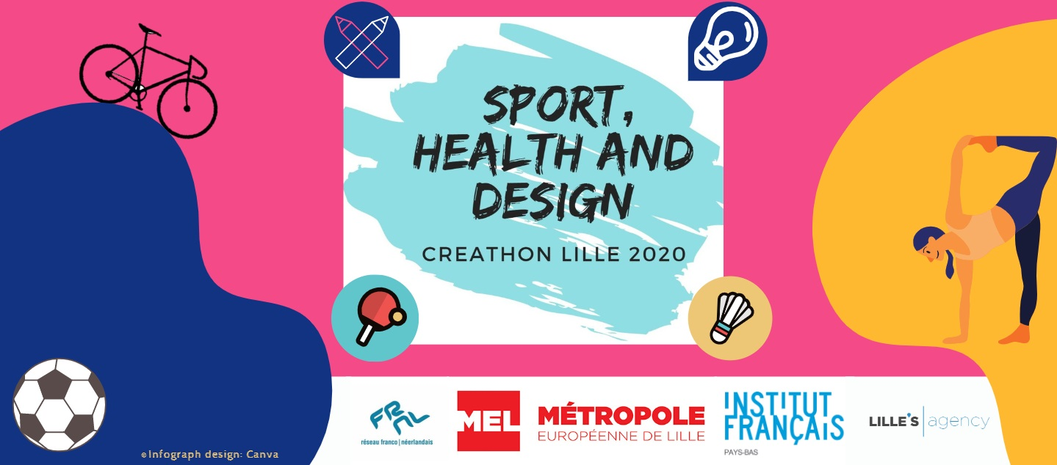
Name: Cliquez ou appuyez ici pour entrer du texte.
Date of birth: Cliquez ou appuyez ici pour entrer une date.
University: Cliquez ou appuyez ici pour entrer du texte.
Field of study: Cliquez ou appuyez ici pour entrer du texte.
BA ☐ in Cliquez ou appuyez ici pour entrer du texte.
MA ☐ in Cliquez ou appuyez ici pour entrer du texte.
PhD ☐ in Cliquez ou appuyez ici pour entrer du texte.
Postal address:Cliquez ou appuyez ici pour entrer du texte.
/ @ : Cliquez ou appuyez ici pour entrer du texte. / Cliquez ou appuyez ici pour entrer du texte.

1) Briefly describe your relationship to the topic of the Creathon: Sport, Health and Design. How would you connect these three themes? What projects regarding this subject have you been / are you currently working on? (150-250 words)
Cliquez ou appuyez ici pour entrer du texte.

2) Explore the Lille Metropolis and your own city region via maps, websites, books and your personal travel experiences if any. What is your perception of this European territory? How can the Lille Metropolis, Belgium and the Netherlands innovate and strengthen their mutual ties in the various domains regarding sport, design and health? (200-300 words)
Cliquez ou appuyez ici pour entrer du texte.

3) Please join a brief CV to this application form.

Please send your application to Magalie Herlem and Lex Kuil
mherlem@lillemetropole.fr I lex.kuil@univ-lille.fr I http://nlfr.eu/

