Application form (please fill in digitally before September 28, 2020)

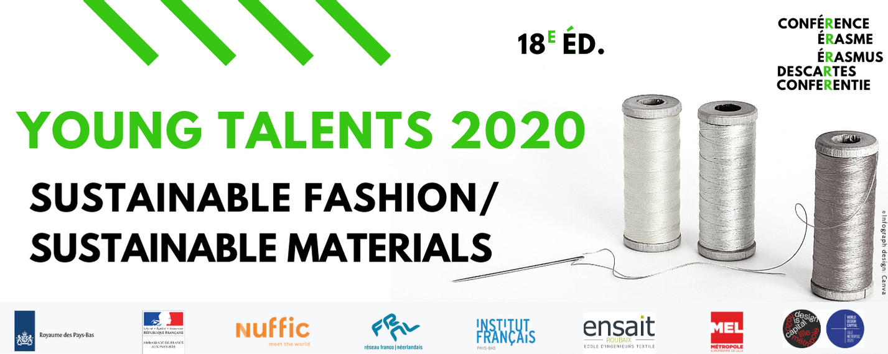

Name: Click here to enter text.
Date of birth: Click here to enter text.

Young professional
Profession/field: Click here to enter text.
Company/start-up/current project: Click here to enter text
Website / link to portfolio / LinkedIn: Click here to enter text
Study background: Click here to enter text

Student
University: Click here to enter text.
Field of study: Click here to enter text.
BA ☐ expected/obtained in Click here to enter text.
MA ☐ expected/obtained in Click here to enter text.
PhD ☐ expected/obtained in Click here to enter text.

Postal address (street, code, city): Click here to enter text.
(Mobile phone nr.): Click here to enter text.
@: Click here to enter text.

1) Briefly describe your relationship to the main theme of the event: Sustainable fashion / sustainable materials. What projects regarding this topic have you been or are you currently working on? Why do you consider yourself a Young Talent when it comes to Sustainable fashion? (200-250 words in English).

2) What are your preliminary ideas about new forms of collaboration between France and the Netherlands in the field of Sustainable fashion and sustainable materials (innovation, new technologies, etc.)?

3) Please attach a brief CV to your application form

Please send your application form with your CV in one PDF file to Anièce Lawniczak and Lex Kuil
alawniczak@nuffic.nl I lex.kuil@univ-lille.fr I http://nlfr.eu/

